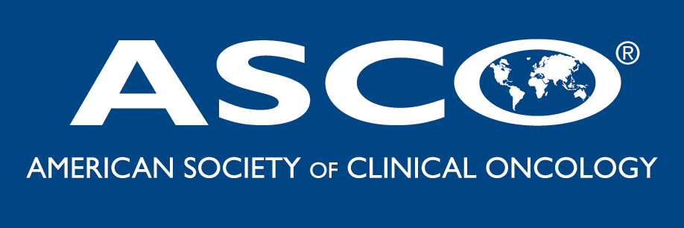

ADAPTING TO CHANGES IN MEDICARE

ASCO is pleased to present an audioconference to help your practice understand and implement changes to coding for drug administration services and the new cancer care demonstration project. The conference will include an interactive Q & A session.

You and your practice staff are invited to join us for a
90-minute national conference call.

    

Thursday, January 6, 2005, 4:00pm EST

    

To participate in this free call, please RSVP by email
by close of business on Wednesday, January 5 to
ASCO’s Cancer Policy & Clinical Affairs Department –
Be sure to include your name– once you RSVP you will receive the call in information and program materials!
ascoaudioconference@asco.org

.

